1. Conclusion of our previous work:

In our first part of work, we have finished the basic UI design for all the pages. And the basic function of our module has been done, including sign in and register, dashboard, inbox, user profile and editing function, projects, group’s members and so on.

For the model part, we have finished the definition of our user, group, group projects, sub-group projects and individual projects. As you could see, the relationship of them are a little complex. Here is a graph describing their relationship.

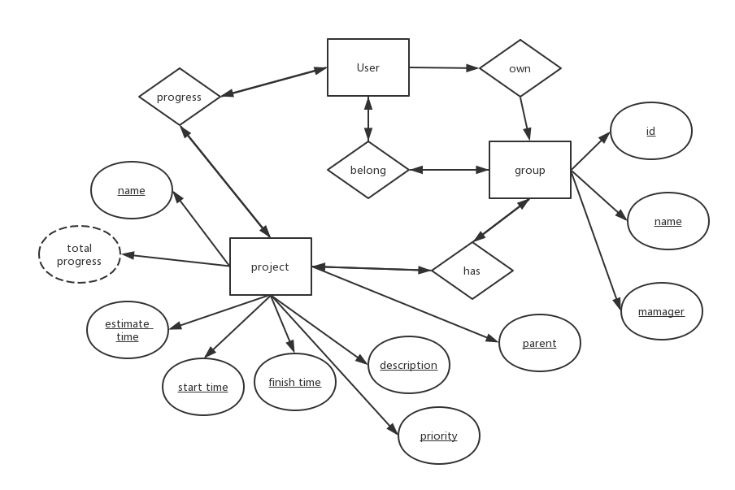

2. To do

(1) Inbox Module:

We want to build a website inbox and the emails could be classified according to their group. For example, if someone in your web group sent you a message, it could be classed as WEB. Besides, you could send someone images, a link or attachment in your inbox.

So next time, our inbox function should work.  There are some tasks.

0. Design the validation form (Approximate time: 1 hours)

1. Design the inbox module (Approximate time: 1 hours)

2. Link the models with other models like user or group(Approximate time: 3 hours)

-- Xinyi Li

(2) Inbox notification module:

As you could see, we want to inform the user if they are lacking behind. So we want to send them emails or inbox messages to notify them. Therefore, we want to link this function with our project progress and email sending function. Besides, if the user choose to mute notification, we will make it not work.

There are some tasks.

0. Design the email sending function (Approximate time: 2 hours)

1. Get the progress for each user every day (Approximate time: 2 hours)

2. Check the progress with estimated progress (Approximate time: 3 hours)

3. Add mute function (Approximate time: 2 hours)

-- Xinyi Li

(3) Groups module:

We want to build add group function for the manger and group member. So we want make the website linked with our database.

0. Write group building function (Approximate time: 1 hours)

1. Link the website data with database (Approximate time: 2 hours)

-- Juntao Li

(4) Profile module:

User could now edit their first name and last name feature. However, we want to modify more parameter of the users. So we should extend our user module.

We can separate this task into several sub-tasks:

1. Extend the user module. (Approximate time: 1.5 hours)
2. Link the website with our new models (Approximate time: 1.5 hours)
3. Modify database setting (Approximate time: 1.5 hours)

-- Yaxi Li

(5) Projects module:

Users can add projects, start and finish projects. Many users can choose the same projects.

1. Build the UI for add projects, start and finish project. (Approximate time: 1.5 hours)
2. Store data and retrieve data from database. (Approximate time: 1.5 hours)

-- Juntao Li